**Desktop Flow**

**Exercise 1 - Read Data from Excel sheet – Desktop UI flow**

1. Create a Excel file and some data
2. Open Power Automate Desktop
3. Click **New Flow**
4. Enter flow name **ReadExcelUIflow**

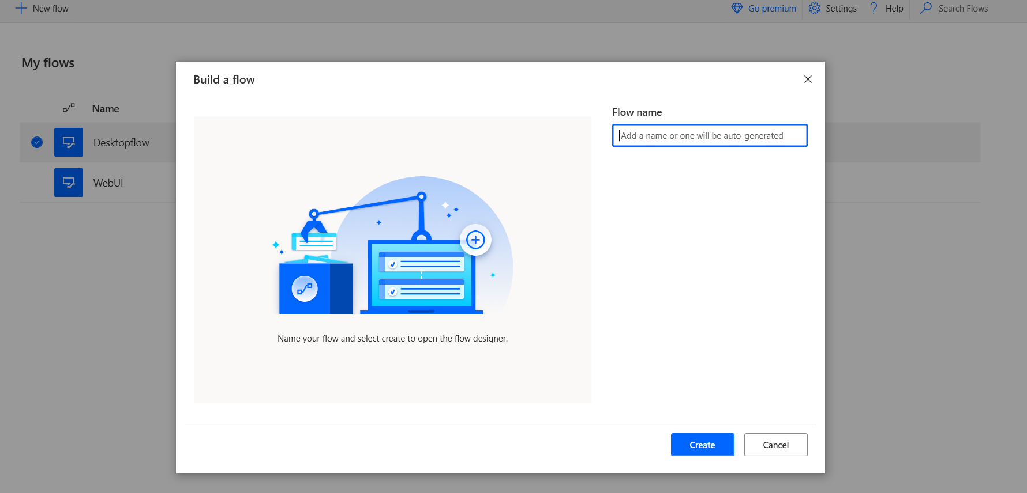

1. Click **Create**
2. Its open desktop flow designer

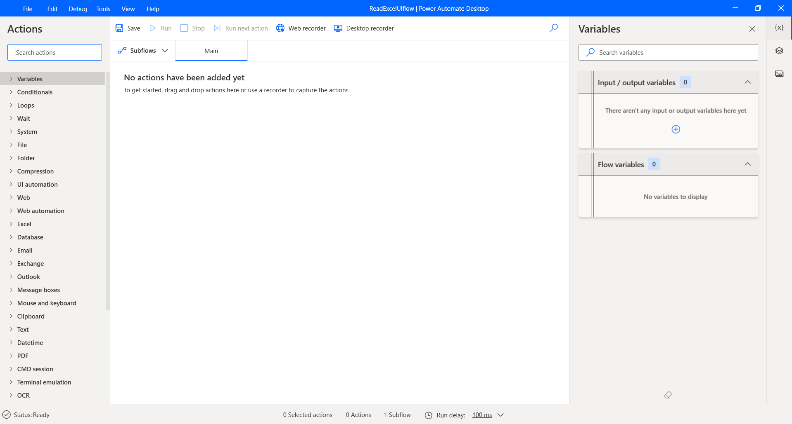

1. Add **Get specify folder** to the designer

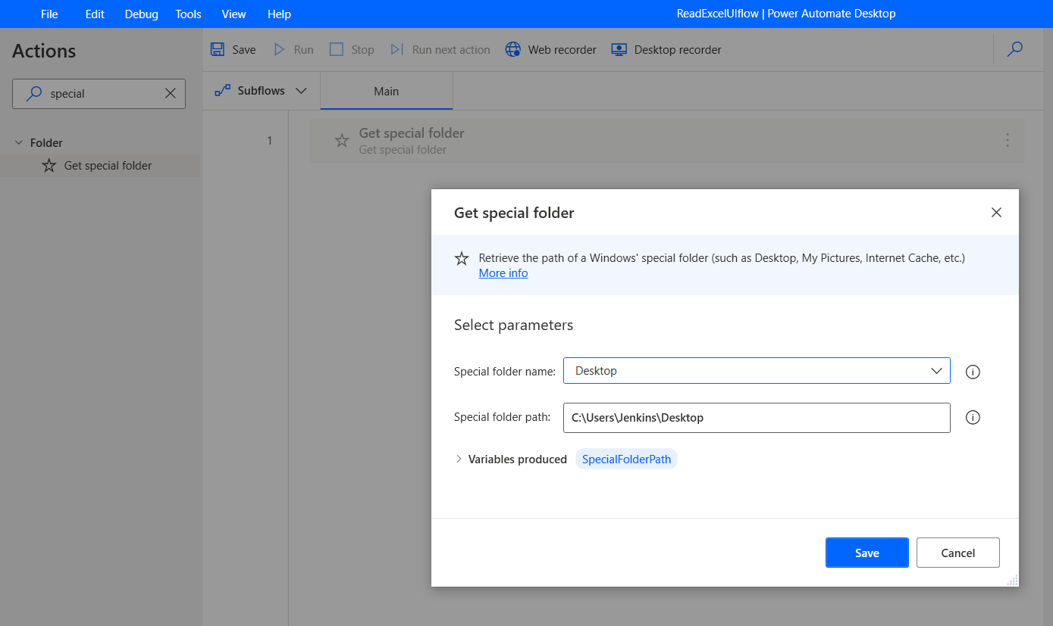

1. Update the Variable produced to **folderpath**
2. Set Variable to specify the path

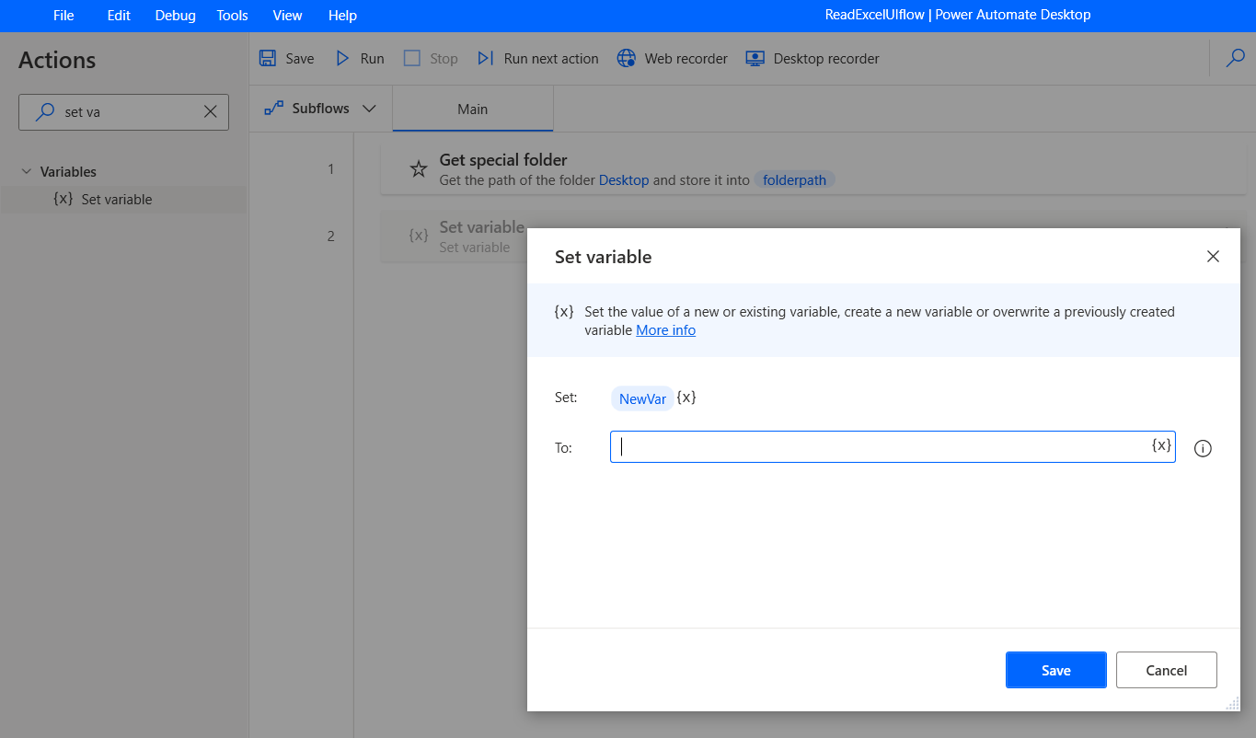

1. Set – **filepath**
2. To – update the file path

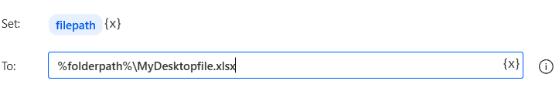

1. Launch Excel
2. Change to **open the following document**

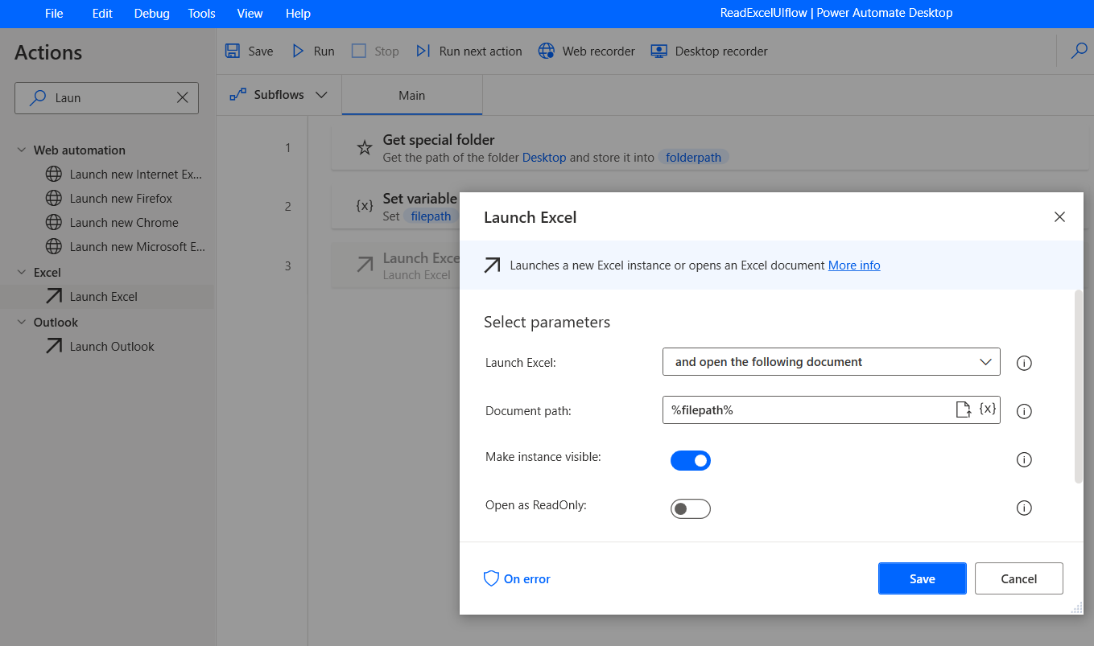

1. Document path to – filepath variable
2. Click **Save**
3. Add **Get first free column/row from excel worksheet**

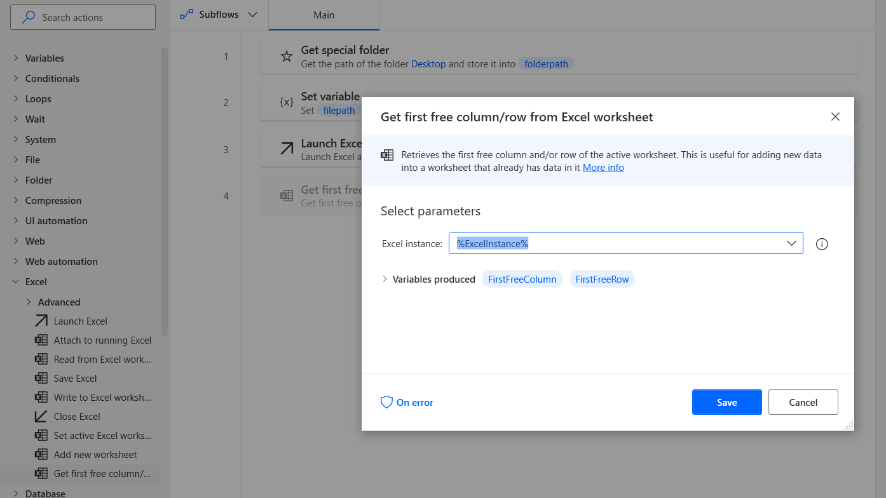

1. Click **Save**
2. Add **Read from Excel worksheet**

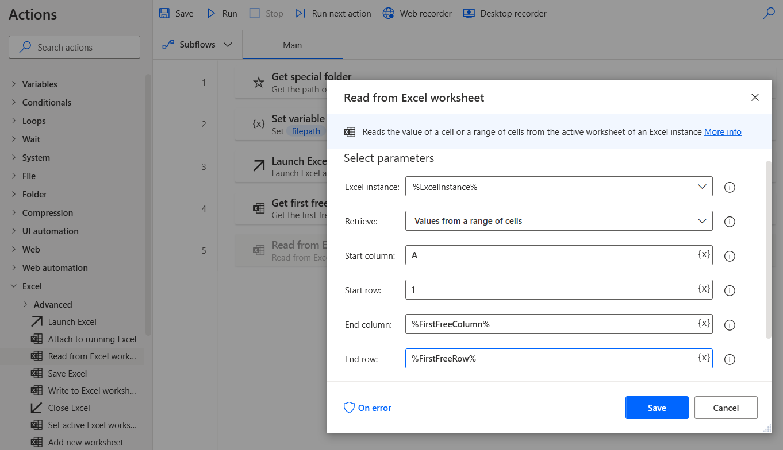

1. Retrieve from a range of cells
2. Start column A
3. Start row 1
4. End Column - select the FirstFreeColumn-1
5. End row - select the FirstFreeRow – 1

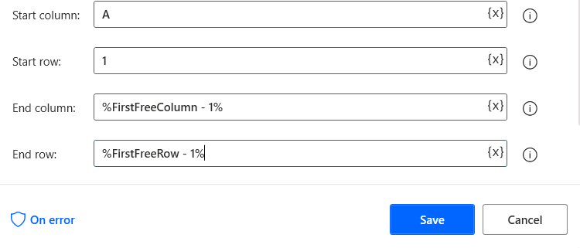

1. Add Display Message to display the message

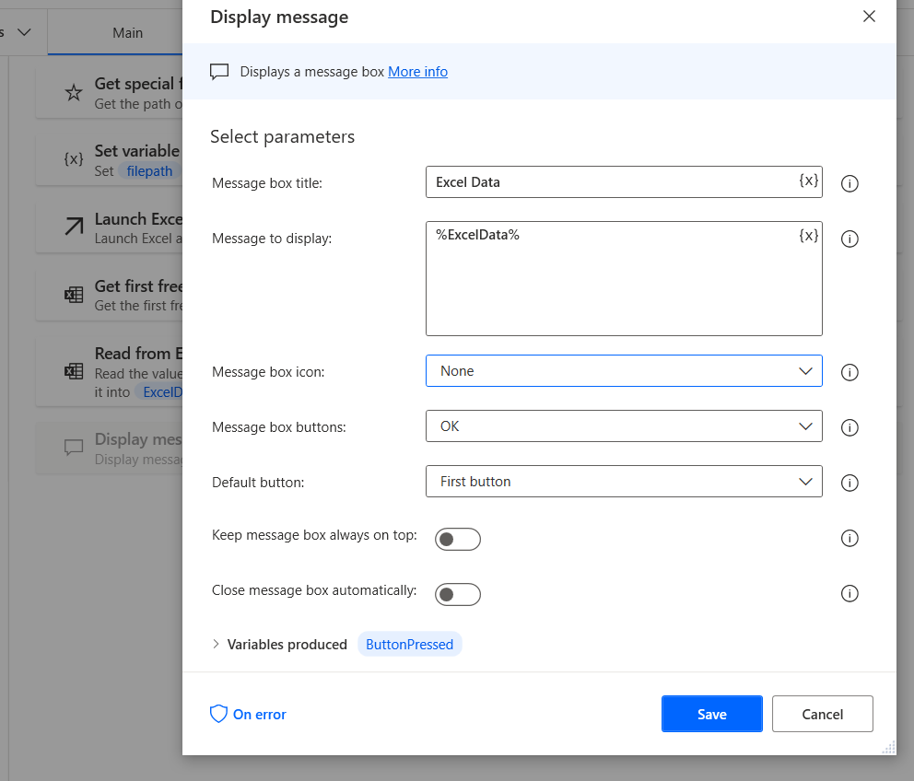

1. Message to display – **Exceldata**
2. **Save it**
3. **Save** the flow
4. **Run** it

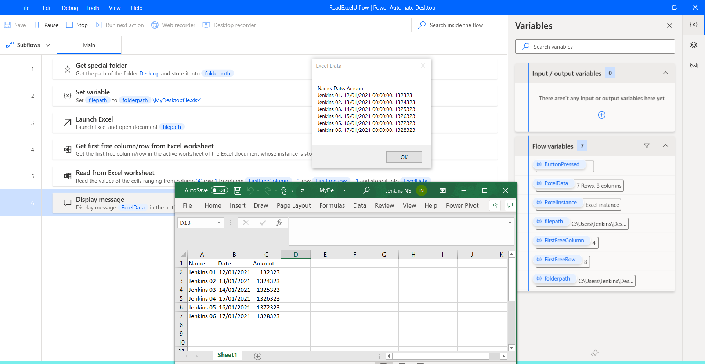

1. All Steps

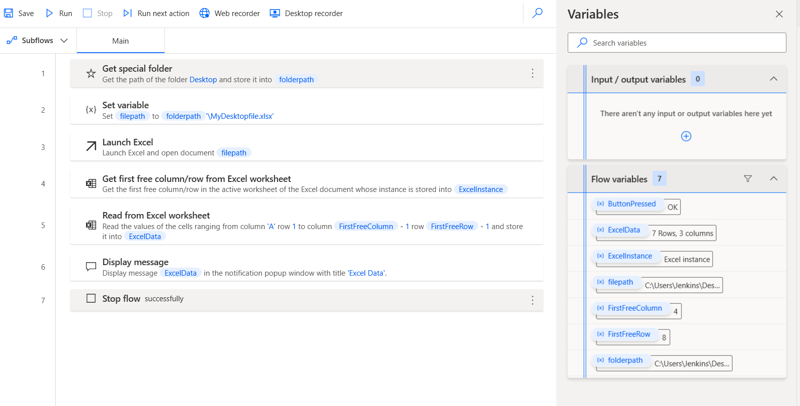

Done.

**Exercise 2 - Read Data from website and save it in excel file**

1. Open Power Automate Desktop
2. New Flow

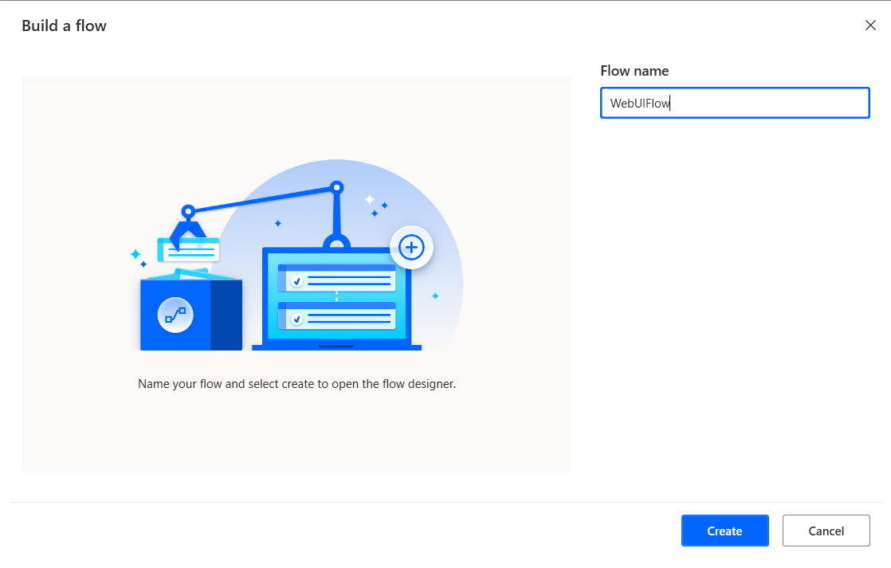

1. Create
2. Open flow Designer

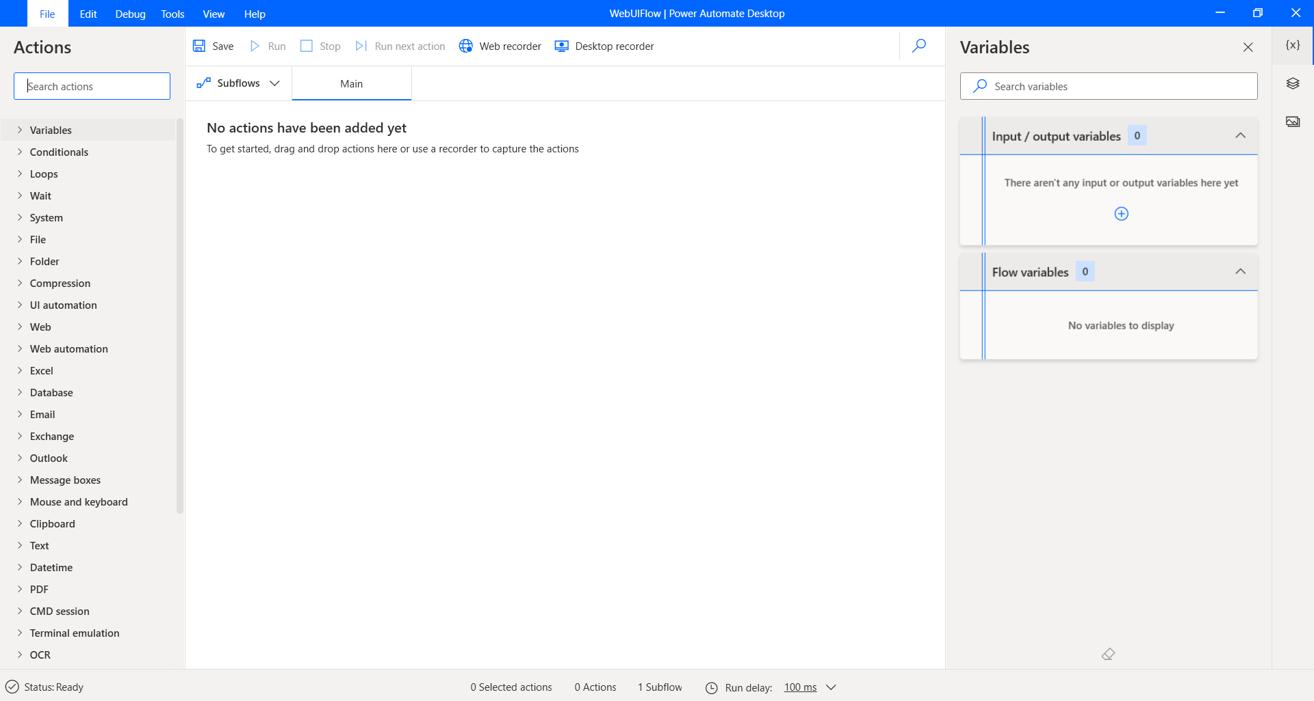

1. Click Web recorder

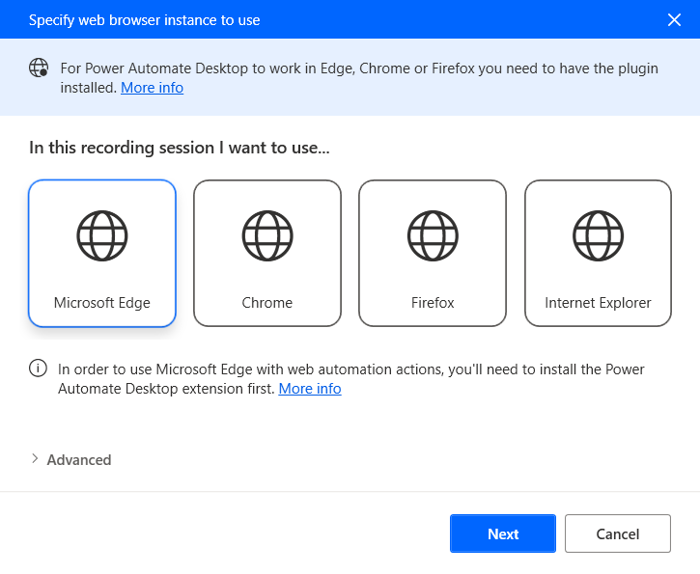

1. Select Microsoft Edge 🡪 Click Next
2. Update the url to -> <https://kumarispecial.com>
3. Click finish

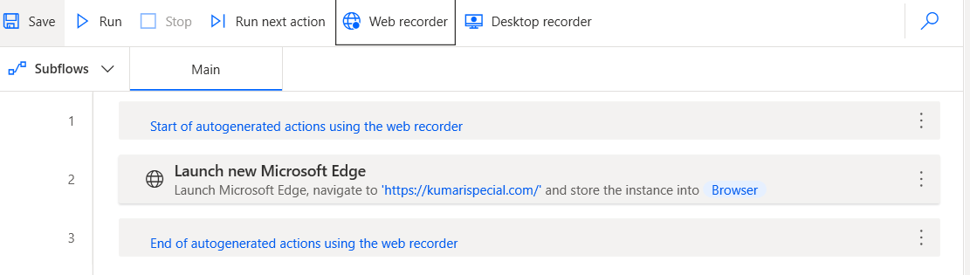

1. Go to Actions 🡪 Web automation 🡪 Web data extraction
2. Select Extract data from web page
3. Open the webpage
4. It will open live web helper
5. Select the data you want to extract, right click and select the item.

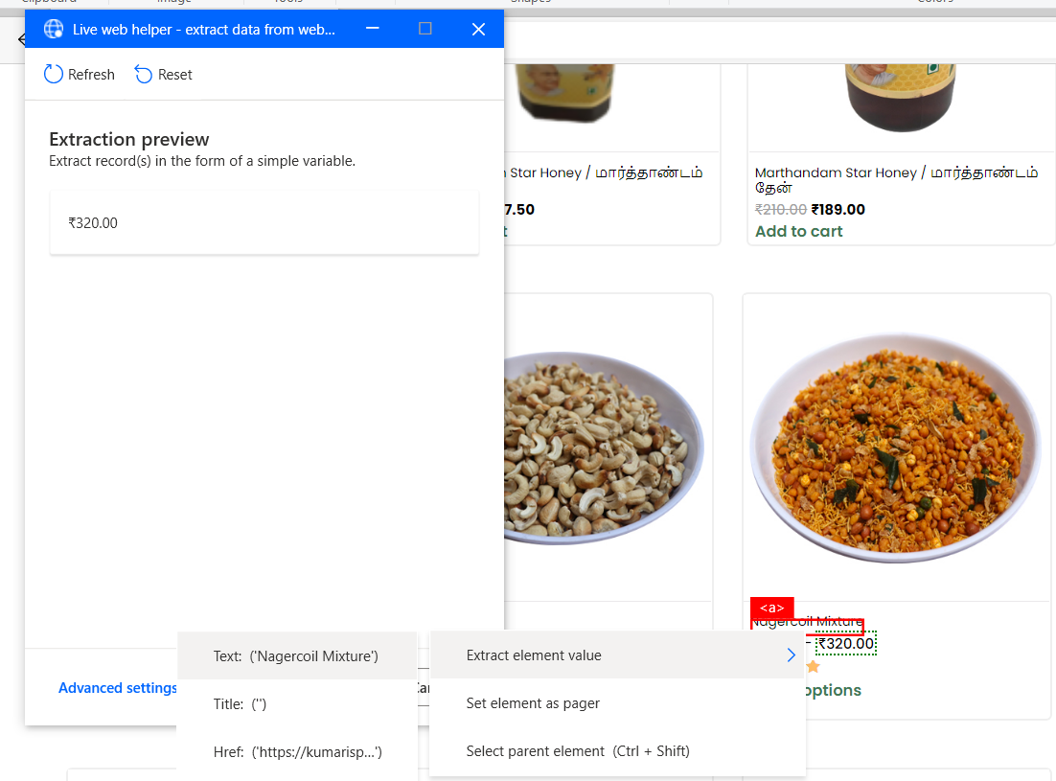

1. Select all data for single item
2. Then select the second item
3. It will bring all data
4. Then finish it
5. Change the Store data mode to Excel spreadsheet

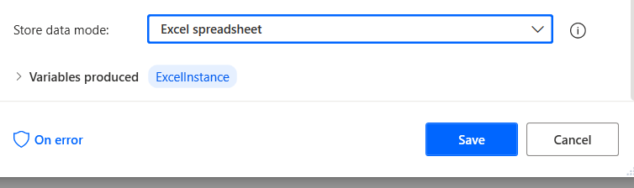

1. Save it
2. Run it, it read all data and generate excel file.

